JAVA GET STARTED:

=>In Java, every application begins with a class name, and that class must match the filename.this statement is followed in any tutorial but it is not true the file might differ from class name but the thing whenever code need to be executed while compiling syntax is

1st step 🡺javac filename(file name should be foolowed by.java)

2nd step 🡺java classname

* 1. **name of file is hi**

* 1. name of class is Hansi

🡺if u look at both images eventhough class name and file name is different we can compile and run

* 1. compiling

* 1. running

ABOVE HELLO WORLD PROGRAM WITH CHANGES IN CODE

1)

1)here [] got shifted from args right side to strings right.in older versions it is not possible but later it has been implemented bcz to be easy to new comers from other language background

2)

Here I changed array name from args to hansi the parameter after String is array name it can be changed as ur wish .let us see it is array or not.

But after compiling i.e., while running u need to give value or values to array as array is hansi[] of no size we can give as many as values u like all the values need to after name and each value need to separated by space as in below image.

NOTE: Eventhough we entered numbers they are stored as strings later we need to type cast them.

3) **class is declared as public**

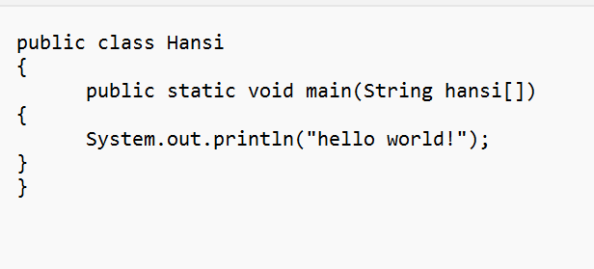

🡺When class is declared as public then the class name and file name should match each other if not throws an error as below

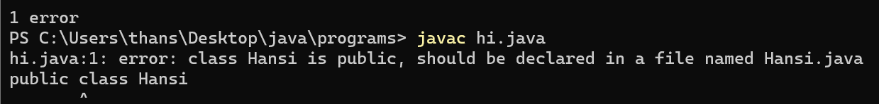

🡺So now I need to change file name from hi.java to Hansi.java(not hansi.java bcz class name and file name should be same)

or

🡺U can save both class and file name as hansi and hansi.java

Constructors:

<https://www.javatpoint.com/java-constructor>